Name: Wenda Zhao
(113 pts in total)
Introduction:
This assignment will use a database containing data about a university. You need to create all the tables/relations from the .txt files as attached. (You can use the psql command ‘\copy’ to load the text data into database. NOTE: Remove the first schema line from the data file before using \copy. You can find an example in the attached slides.)

The schema of the database is provided below (keys are in bold and underlined, field types are omitted):

- student(sid, sname, sex, age, year, gpa)
- dept(dname, numphds)
- prof(pname, dname)
- course(cno, cname, dname)
- major(dname, sid)
- section(dname, cno, sectno, pname)
- enroll(sid, grade, dname, cno, sectno)

Note: Some students have not declared a major.

A. Queries (Student Database)
Write SQL queries that answer the questions below (one query per question). The query answers must not contain duplicates, but you should use the SQL keyword distinct ONLY when necessary. Submit both the queries (text form) and the screen shot of the execution of each query including the returned results. Your queries will be graded based on both the correctness and the succinctness.

Questions
- For each Computer Sciences class, print the cno, sectno, and the average gpa of the students enrolled in the class. (6 pts)

SELECT e.cno, e.sectno, AVG(s.gpa)
FROM enroll e JOIN student s ON e.sid=s.sid
GROUP BY e.cno, e.sectno, e.dname
HAVING e.dname='Computer Sciences';

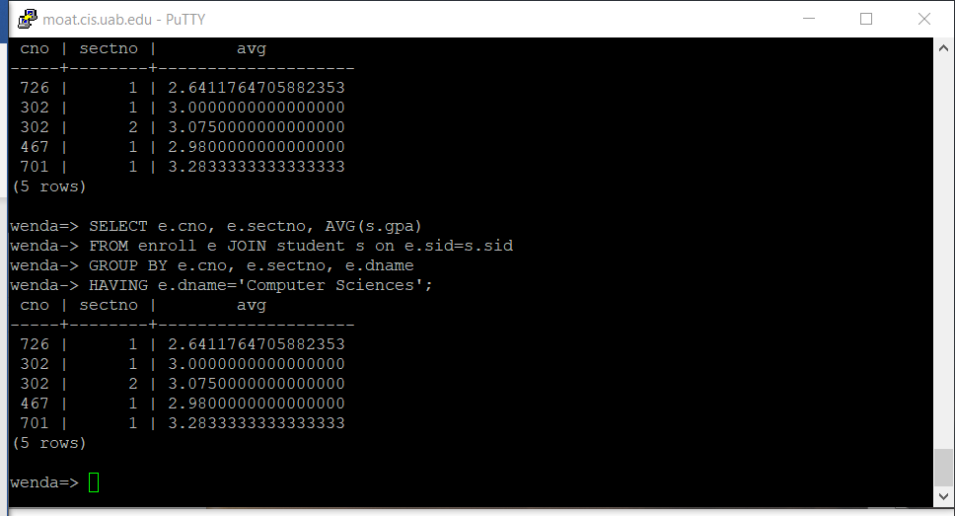

- Print the course names, course numbers and section numbers of all classes with less than six students enrolled in them. (8 pts)

SELECT c.cname, e.cno, e.sectno
FROM enroll e FULL JOIN course c ON (e.cno=c.cno AND e.dname=c.dname)
GROUP BY e.cno, e.sectno, e.dname, c.cname
HAVING COUNT(e.sid)<6;

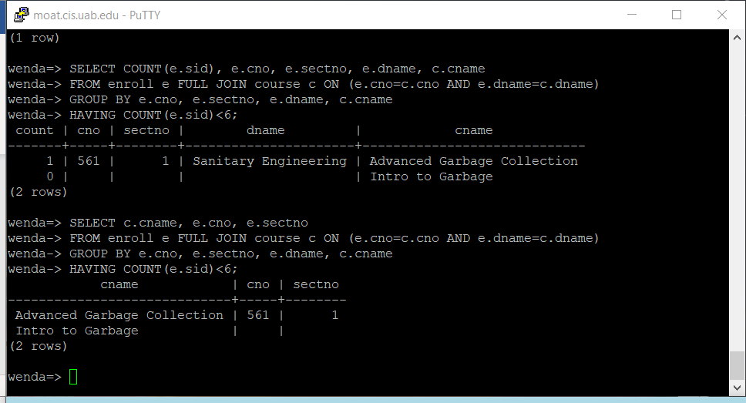

- Print the names of departments that have one or more majors who are under 18 years old. (8 pts)

SELECT m.dname
FROM student s JOIN major m ON (s.sid=m.sid)
WHERE s.age<18;
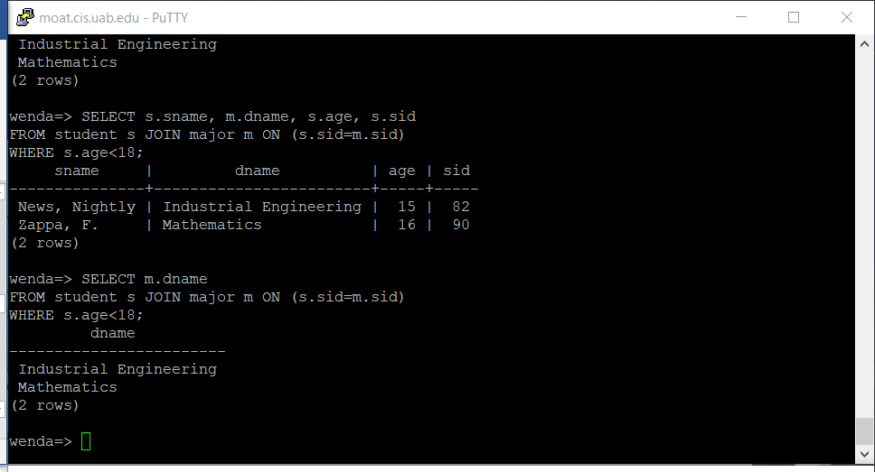

- Print the names and majors of students who are taking one of the College Geometry courses. For students who do not have a major, print out some special string, e.g., an empty string, as his/her major. (Hint: You'll need to use the "like" predicate and the string matching character in your query. You also likely need to use SET operations.) (12 pts)

SELECT s.sname, coalesce(m.dname, 'empty')
FROM student s FULL JOIN major m ON (s.sid=m.sid)
WHERE s.sid IN (SELECT e.sid
FROM enroll e JOIN course c ON (e.cno=c.cno)
WHERE c.cname LIKE 'College Geometry%');
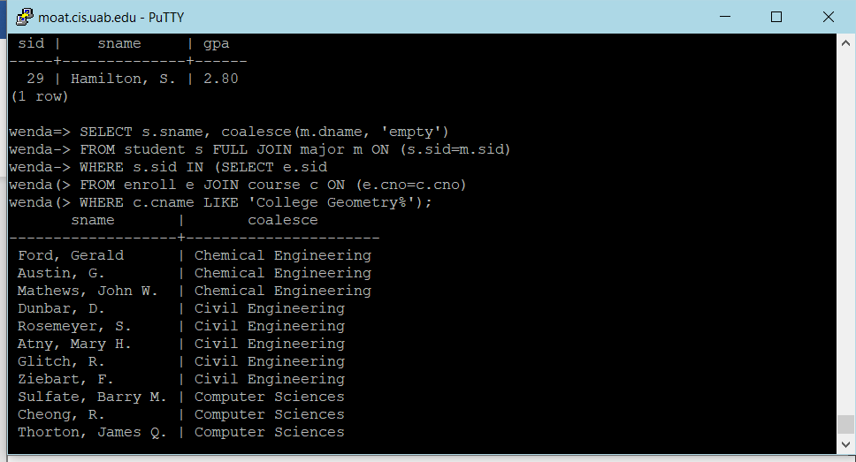
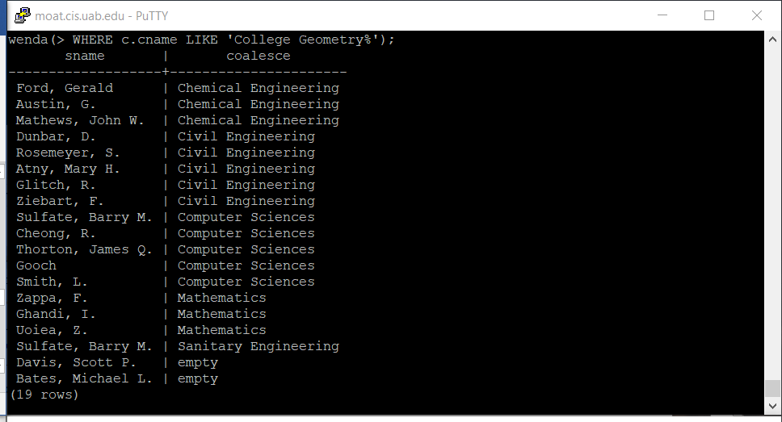

- For those departments that have no majors taking a College Geometry course, print the department name and the number of PhD students in the department. (12 pts)

SELECT d.dname, d.numphds
FROM dept d
EXCEPT
(SELECT d.dname, d.numphds
FROM (SELECT distinct m.dname
FROM student s JOIN major m ON (s.sid=m.sid)
WHERE s.sid IN (SELECT e.sid
FROM enroll e JOIN course c ON (e.cno=c.cno)
WHERE c.cname LIKE 'College Geometry%')) AS temp, dept d
WHERE d.dname = temp.dname);
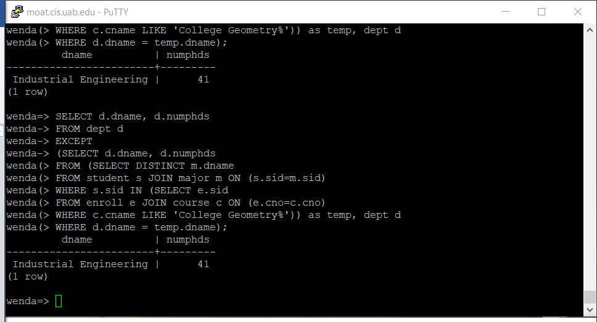

- Print the names of students who are taking both a Computer Sciences course and a Mathematics course. (12 pts)

SELECT s.sname
FROM enroll e JOIN student s ON (s.sid=e.sid)
WHERE e.dname='Computer Sciences'
INTERSECT
SELECT s.sname
FROM enroll e JOIN student s ON (s.sid=e.sid)
WHERE e.dname='Mathematics';
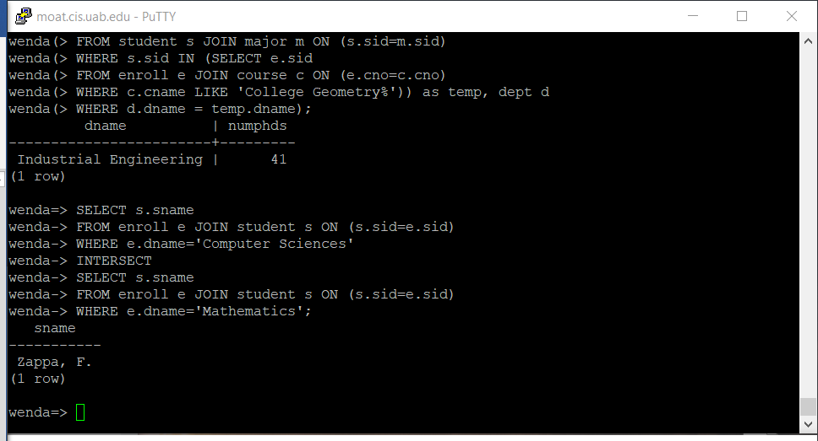

- Print the age difference between the oldest and youngest Computer Sciences major(s). (10 pts)

SELECT MAX(s.age) - MIN(s.age) AS age_difference
FROM student s JOIN major m ON (s.sid=m.sid)
WHERE m.dname='Computer Sciences';
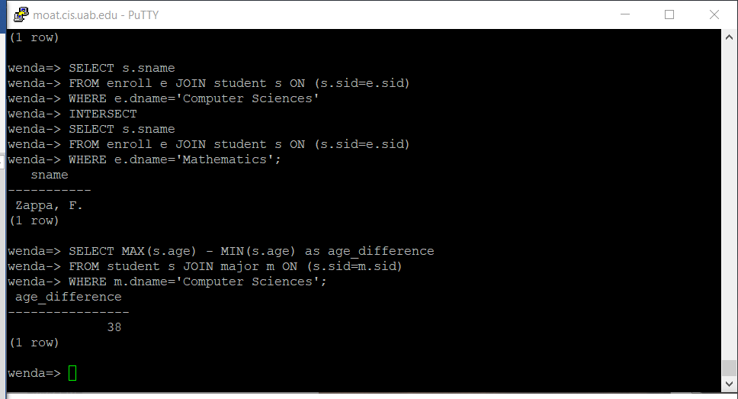

- For each department that has one or more majors with a GPA under 1.0, print the name of the department and the average GPA of its majors. (15 pts)

SELECT mdn.dname, ag.avg
FROM (SELECT m.dname
FROM student s JOIN major m ON (s.sid=m.sid)
WHERE s.gpa<1.0) as mdn
JOIN (SELECT m.dname, AVG(s.gpa) as avg
FROM student s JOIN major m ON (s.sid=m.sid)
GROUP BY m.dname) as ag
ON (mdn.dname=ag.dname)
GROUP BY mdn.dname, ag.avg;
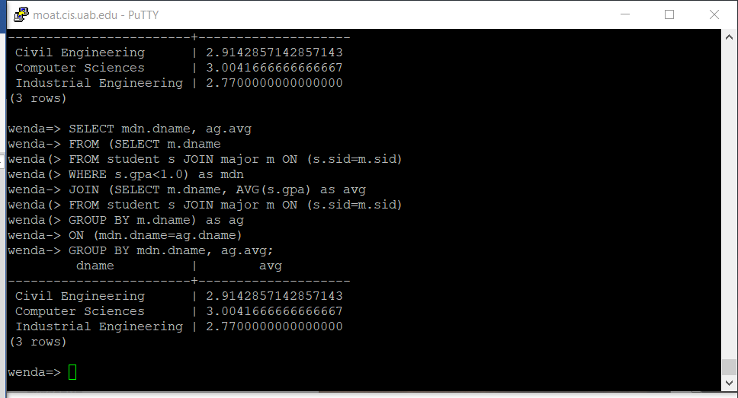

- Print the ids, names, and GPAs of the students who are currently taking all of the Civil Engineering courses. (15 pts)

SELECT s.sid, s.sname, s.gpa
FROM student s
WHERE sid=(SELECT e.sid
FROM enroll e
WHERE dname='Civil Engineering'
GROUP BY e.sid
HAVING COUNT(e.cno) = (SELECT COUNT(s.cno) as count_courses
FROM section s
WHERE s.dname='Civil Engineering'));
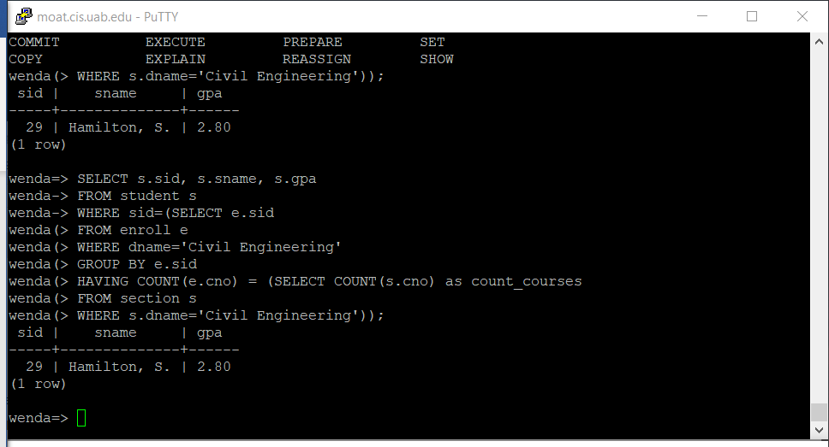

B. More SQL Queries (Product Database)
Write the following queries, based on the database schema:

Product(maker, model, type)
PC(model, speed, ram, hd, price)
Laptop(model, speed, ram, hd, screen, price)
Printer(model, color, type, price)

The Product relation gives the manufacturer, model number and type (PC, laptop, or printer) of various products. We assume for convenience that model numbers are unique over all manufacturers and product types. The PC relation gives for each model number that is a PC the speed(in Ghz), the amount of ram (in MB), the size of the hard disk (in GB), and the price. The Laptop relation is similar, except that the screen size (in inches) is also included. The Printer relation records for each printer model whether the printer produces color output (true if so), the process type (laser or ink-jet, typically), and the price.

- (7 points) Find the average price of PC’s and laptops made by manufacturer “D.”

(SELECT AVG(pc.price)
FROM pc JOIN product pr ON (pc.model=pr.model)
WHERE pr.maker='D.')
UNION
(SELECT AVG(l.price)
FROM laptop l JOIN product pr ON (l.model=pr.model)
WHERE pr.maker='D.');
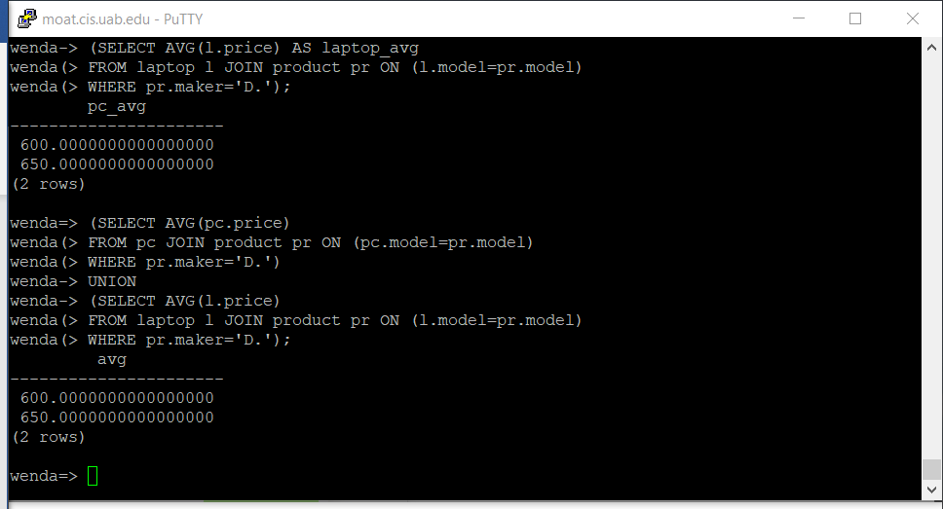

- (8 points) Find the average hard disk size of a PC for all those manufacturers that make printers.

SELECT AVG(pc.hd)
FROM product pr JOIN pc ON (pc.model=pr.model)
WHERE pr.maker IN (SELECT pr.maker
FROM product pr
WHERE pr.type='printer');
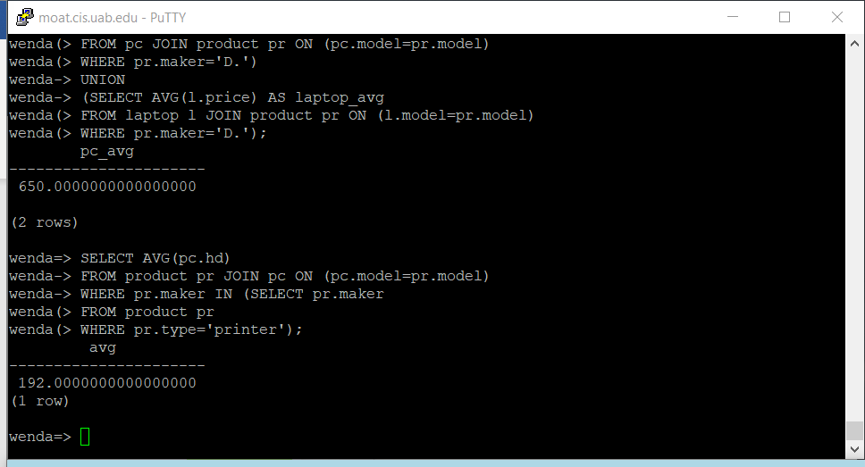

NOTE: You need to create your own test tables and output the results. Submit both the queries (text form) and the screen shot of the execution of each query including the returned results. Your queries will be graded based on both the correctness and the succinctness.

Assignment Submission

This is an individual assignment – no group submissions are allowed. Submit to Canvas:

- Your SQL statements and query results.
- Your DB name, web username, and web user password.

DB name: wenda
Web username: wendaweb
Web user password: ZHAOWENDAyjjw0809

I, Wenda Zhao, declare that I have completed this assignment completely and entirely on my own, without any consultation with others. I understand that any breach of the UAB Academic Honor Code may result in severe penalties.

